Klinik für Kinderheilkunde III
Hämatologie/Onkologie, Pulmologie Kardiologie, Rheumatologie

Direktor: Prof. Dr. med. Dirk Reinhardt Büro: Stephanie Freund kinderonkologie@uk-essen.de
https://kinderklinik3.uk-essen.de/

Stellvertretende Direktorin:
Prof. Dr. med. Uta Dirksen

Geschäftsführende Oberärztin:
Prof. Dr. med. Gudrun Fleischhack
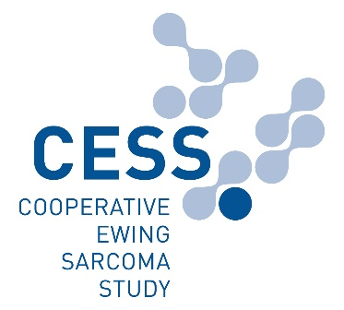
Klinik für Kinderheilkunde III

Internationale EWING Studienzentrale

Sarkomzentrum
Westdeutsches Tumorzentrum

Studienleitung:
Univ.- Prof. Dr. med. Uta Dirksen

Tel. +49 201 723-8085
Fax +49 201 723-6298
itb-ewing@uk-essen.de

Postanschrift:
Universitätsklinikum Essen
Klinik für Kinderheilkunde III
Internationale EWING Studienzentrale
Margot-von-Bonin Haus
Hohlweg 8
45147 Essen

Universitätsklinikum Essen
Hufelandstraße 55
45147 Essen

Tel. +49 (0) 201 723-0
www.uk-essen.de
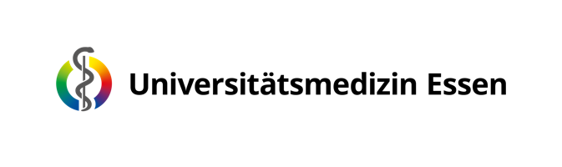

Checklist
CESS Interdisciplinary Tumor Board

Please send all clinical imaging (in DICOM format ONLY)
to the study office ASAP! (see page 2 of this document)

Required documents (in German or English):

Initial ITB presentation:
☐ Case Sheet completed with all pertinent clinical information
and precise question via email in DOCX. format
☐ physician’s reports
☐ initial imaging
☐ initial pathology reports
☐ radiological und nuclear medicine reports
☐ radiotherapy plan (if applicable)
Subsequent ITB presentation following local therapy / relapse:
☐ OP-report
☐ post-operative pathology report
☐ radiotherapy plan (if applicable)
☐ post-operative imaging

Please be aware:
Our regularly scheduled ITBs are held weekly on Friday afternoons. The deadline for the receipt of all images and patient documentation is no later than Tuesday of that week. We kindly request that an email be sent to
itb-ewing@uk-essen.de as soon as the images/documents have been uploaded.

