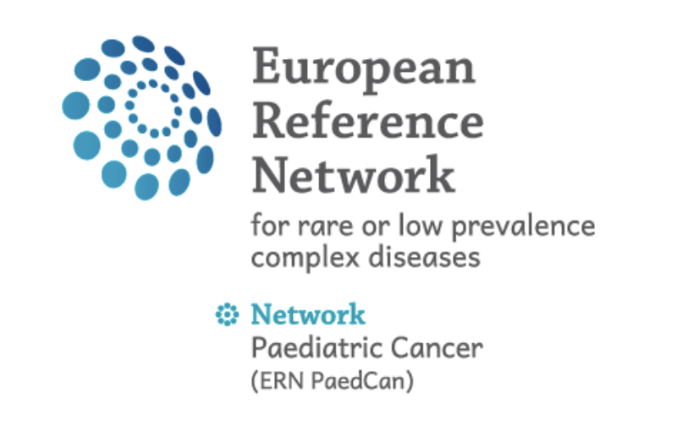

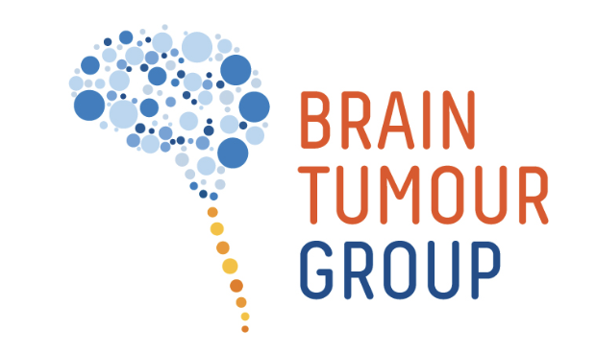

ERN / SIOP-E BTG Rare Embryonal and Sarcomatous CNS Tumour (REST) - Tumour Board

Workflow in brief:

Before meeting
Upload patient data latest Friday 14.00 CET before the meeting:

- Check if a consent is needed at your institution and get consent of the patient if required
- Register the patient with a standardised nickname including the acronym REST, the enrolment date and the institution as e.g.: “REST 20250507 Yourhospital 1”
- Add participants to the patient (select group: “Rare embryonal/sarcomatous brain tumours”)
- Add the clinical information in the .ppt template to be uploaded and presented
- Upload the imaging data – latest Friday 14.00 CET/CEST before the meeting – each relevant DICOM series as separate ZIP file max 2 GB.
- Upload relevant pathology / molecular results as deidentified reports.
- Open discussion in CPMS and include clear question(s) to the Tumour Board

After the meeting:
To create the final Tumour Board document, please close the discussion and copy/paste all relevant information from the discussion into the discussion summary.

See further details below.

Detailed description

Aim
Rare embryonal and sarcomatous tumours of the CNS are rare diseases with no established standard of care. Given the rarity of the diseases, the lack of evidence and the often-poor prognosis, a REST-specific international tumour board is considered of high relevance for improving the treatment of current patients.
The patients will be discussed with a panel of experts in the field, with the aim to share and gain knowledge and to align recommendation in agreement with the recently published European Standard Clinical Practice Recommendations.

To allow future structured analyses and type specific research analyses, inclusion of patient in the SIOP-E BTG CNS-REST Registry should be offered to all patients discussed in the SIOP-E BTG REST Tumour Board.

ERN / SIOP-E BTG CNS-REST Tumour Board Panel
Members of the ERN / SIOP-E BTG CNS-REST Tumour Board Panel are listed below. Further experts may be additionally invited. The Panel may be adapted over time. Members of the Panel are expected to participate and support the meeting regularly.

Discipline | Name |  | Contact Coordinators
Paed Oncology (coordinators) | Katja | von Hoff | katvon@rm.dk
 | Johannes | Gojo | johannes.gojo@meduniwien.ac.at
 | Barry | Pizer
 | Sarita | Depani | sarita.depani@gosh.nhs.uk
 | Darren | Hargrave
 | Pascal | Johann
Molecular biology | Marcel | Kool
Neuropathology | Mariëtte | Kranendonk
 | David | Capper
 | Christine | Haberler
 | Philipp | Sievers
 | Martin | Hasselblatt
Neuroradiology | Anna | Tietze
 | Ulrike | Löbel
 | Maarten | Lequin
 | Kish | Mankad
Neurosurgery | Ulrich | Thomale
 | Eelco | Hoving
 | Oscar | Eelkman Rooda
Radiotherapy | Ajith | Ajithkumar
 | Yasmin | Lassen
 | John | Maduro
Genetics (Contact GENTURIS) on request | Karin | Wadt

Further members of the SIOP-E BTG REST working group and invited guests may participate at the Tumour Board discussions. Colleagues interested to get regular invitations to the CNS-REST Tumour Boards please send their contact details to the Tumour Board Coordinators.

The organisation of the Tumour Board is supported by the clinical research fellows:
Ronja Tügel Carstensen: Ronja.carstensen@clin.au.dk and
Hannah Schned: hannah.schned@meduniwien.ac.at

Meeting times:
The ERN / SIOP-E BTG CNS REST Tumour Board will be held every 2nd and 4th Tuesday
from 16.00-17.00 CET/CEST

Meeting platform:
The meeting is held on the CPMS 2.0 platform: https://cpms2.ern-net.eu/screen/home
The Clinical Patient Management System (CPMS) is a secure and fully GDPR compliant IT platform aiming to facilitate the cross-border discussion of rare clinical cases.
The platform is supervised by the Directorate General for Health and Food Safety (DG SANTE) of the European Commission and funded under the EU4Health Programme.

Further information on the CPMS2.0 platform and the ERN / SIOP-E BTG CNS REST Tumour Board can be found on the ERN PaedCan website: https://paedcan.ern-net.eu/the-clinical-patient-management-system-cpms/

Please note that there can be technical difficulties and firewall issues when joining the CPMS meeting platform. For first time participants, it is therefore recommended to join in 15 minutes earlier and have a private laptop as a backup, in case the system functionality gets blocked from the hospital firewall. In the case of firewall problems, please find further information below. Don’t hesitate to contact the Tumour Board Coordinators.

EU login account
To access the CPMS platform a EU login account is required. This can be created via the link: https://cpms2.ern-net.eu/screen/home.
When registering, you will need to configure a two-factor authentication.
When first accessing the platform a ”sign-up” step will be required. Please select ERN PaedCan as the respective responsible ERN.

Inclusion of a patient on an ERN / SIOP-E BTG CNS REST Tumour Board meeting:
Inclusion may be requested by mail to one of the coordinating physicians (Katja von Hoff: katvon@rm.dk, Sarita Depani: sarita.depani@gosh.nhs.uk, or Johannes Gojo: johannes.gojo@meduniwien.ac.at).

Workflow:
All information on the patient needs to be uploaded on CPMS2.0 until Friday 14.00 CET/CEST in the week before a meeting is held.
The following steps are needed from the requesting physician to upload the patient data.
Information can also be uploaded by an assistant to the referring physician. (see information in the appendix below)

- Check if a consent is needed at your institution and get consent of the patient
Consents for sharing medical data via CPMS for discussion of a patient case are available in all EU languages on the CPMS2.0 website: https://cpms2.ern-net.eu/screen/supporting-documents and the PaedCan website: https://paedcan.ern-net.eu/the-clinical-patient-management-system-cpms/.
Your hospital has a specific form or procedure to obtain consent from a patient for this system. If you are unaware of this internal procedure, please contact your hospital Data Protection Officer (DPO) and/or ERN specific representative.

Please note that there are different levels of consent:
- Primary consent (diagnosis and treatment)
- Secondary consent (education, export to registries)

When you discuss the CPMS with the patient / legal representative, please ask also for consent to educational purposes. This will allow to invite interested colleagues to follow the discussion.

We expect that all patients discussed at the CNS-REST Tumour Board will also be offered participation in the SIOP-E BTG CNS-REST Registry once this is open in the respective national group. Please note that this will require a separate consent.

- Register the patient under the “Add New Patient” tab.
Please assign a standardised nickname including the acronym REST, the enrolment date and the institution as e.g.: “REST 20250507 Yourhospital 1”.
Please insert this assigned name in the “Nickname” section and click on “validate”.

- Add participants: Once the patient is added in the CPMS system, please open the patient file (double click on the patient acronym in your patients list). Then select the tab “participants” and click on the blue button “add participants”. A search window then opens, where you need to select the “search by group” button in the upper-left corner. Then search for “REST” and select the group: “Rare embryonal/sarcomatous brain tumours (CNS-REST)”. After selection, press “Add participant”.

Please note that there is also an educational group for CNS-REST. Due to data protection issues this group will be invited to the meetings but will not have access to the full patient data as the selected Tumour Board Panel members. Therefore, please do NOT add the CNS-REST educational group to the patient file.

- Add the clinical information to the tumour board.
Please summarize the patient information in a slide deck for presentation at the Tumour Board. (please use the slide deck template) and upload this slide deck to the patient files.

Please note we expect a discussion time of 15 min per patient. I.e. please keep the introduction short to 3 maximal 5 minutes.

To get a more detailed and structured overview of the patient’s treatment course, we ask to summarize the patient’s clinical information also in the clinical information form and upload this as a separate file.

- Please upload imaging data.
- Please upload the DICOM data of all relevant MRI evaluations in the files section.
- Preoperative MRI
- Postoperative MRI
- Spinal MRI
- Further staging evaluations in case of suspicion or evidence of metastatic disease
- Further relevant follow-up MRI
- MRI in case/suspicion of relapse
- Relevant current MRI

Please be aware that each imaging needs to be uploaded in a separate file.
Please insert date of imaging acquisition (“investigation date”) at the upload. This is very important to match the images to the relevant clinical time point.
The process may require some time; therefore, we recommend starting upload with the most recent series and the respective most important baseline/comparison and initial imaging.

Please note: DICOM files musts be uploaded contained in zip-files. The size limit for a single zip file is 2GB. As many files as necessary can be uploaded.

In principle, DICOM data will be deidentified at the upload, but note that the responsibility for deidentification lies at the submitting institution.

- Please list the uploaded MRIs and the respective acquisition dates in the clinical information sheet (appendix.) This will facilitate the neuroradiology panel members to match the uploaded series to the clinical course of the patients.

- Please upload relevant pathology/molecular results.
Please upload all relevant pathology and molecular results reports to the files section of the patient record.

Essential information:
- Scan of complete detailed reports (not just the summary) of all histological and molecular analyses
- Specifically, the original DNA methylation report(s), including Sentrix ID is/are required

Desired information:
- Digitized slides or at least a few representative pictures (e.g. high and low magnification H&E)

Please note that lack of providing this information may render the patient ineligible for the discussion in the Tumour Board.

Please note that all uploaded files need to be de-identified.

- Open the discussion
In order to facilitate that Panel Members commenting on the case, the discussion needs to be opened. Please click on “open discussion” on the right side of the patient file.
Please include an abbreviated summary including relevant information and a precise question to the Tumour Board in the discussion section.

After the discussion:

Please close the discussion after the Tumour Board.
It is recommended to close the discussion soon after the Tumour Board, but not on the same day, as additional comments may be added after the Board.

You can close the discussion by clicking on the blue “close discussion” button. You will be asked to fill in a summary. Only the text from your summary will be shown in the official Tumour Board Outcome document.

Once the discussion is closed, you can print out the Tumour Board Outcome document from the “history” section of the patient file.

Appendix – supplementing information

Supporting documents
Please find supporting documents and videos/webinars related to the CPMS use here: https://cpms2.ern-net.eu/screen/supporting-documents

Add assistant
It is possible to add an assistant to ones CPMS account. The assistant can then insert and upload patient information on behalf of the referring clinician.
The assistant can be added in the “My Account” section by selecting “Assistant” and then clicking the blue “Add Assistant” button.
Detailed information on how to add an assistant is available in the supporting documents, or you can contact the Tumour Board Coordinators for further information.

Firewall issues
In case of firewall problems, please check the latest CPMS FAQs, which can be found in the supporting documents section:

Screenshot from the current latest FAQ document (version 1.5 from 7.10.2025):

