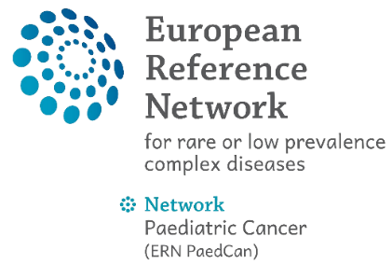
St. Anna Kinderkrebsforschung GmbH
Children’s Cancer Research Institute GmbH
Zimmermannplatz 10, 1090 Vienna, Austria
ATU-75914147

(place, date)

Reference: Reimbursement Request – ERN PaedCan Twinning Programme 2026

Dear ladies and gentlemen,

with reference to ERN PaedCan Training/ Twinning on (date) in (town, country), I am sending you my reimbursement request as follows:

Accommodation costs:
Number of overnight stays:
Unit cost rate / night (please see Annex I for the rate):
Unit cost reimbursement for accommodation (A) (number of nights multiplied by the unit cost rate): | € 0,00
Daily allowance:
Duration of your stay (number of days spent travelling)
Unit cost rate / day (please see Annex I for the rate):
Unit cost reimbursement for daily allowance (B) (number of days spent travelling multiplied by the unit cost rate): | € 0,00
Flight cost:
Flight leaving from (enter the name of the city):
Destination (enter the name of the city):
Distance band (please see Annex I and the calculator):
Unit cost reimbursement for the flight (C) (take the rate from Annex I / Calculator): | € 0,00

Total reimbursement requested (A+B+C) | € 0,00

Name: please fill in
Institution: please fill in
E-mail address: please fill in

Please transfer the amount to following bank account:
Bank institution: please fill in
Recipient: please fill in
IBAN: please fill in
BIC: please fill in

I confirm the truth and accuracy of the invoice. Please find attached the original invoices and boarding passes to this invoice.

Kind regards,

________________________________
(Signature and name of recipient)

Contact person at the Coordinating institution:
Adriana Cantoran
St. Anna Kinderkrebsforschung GmbH
+43 664 5401247
adriana.cantoran@ccri.at

Annex I – Unit Cost Rates

- Accommodation unit-cost rates: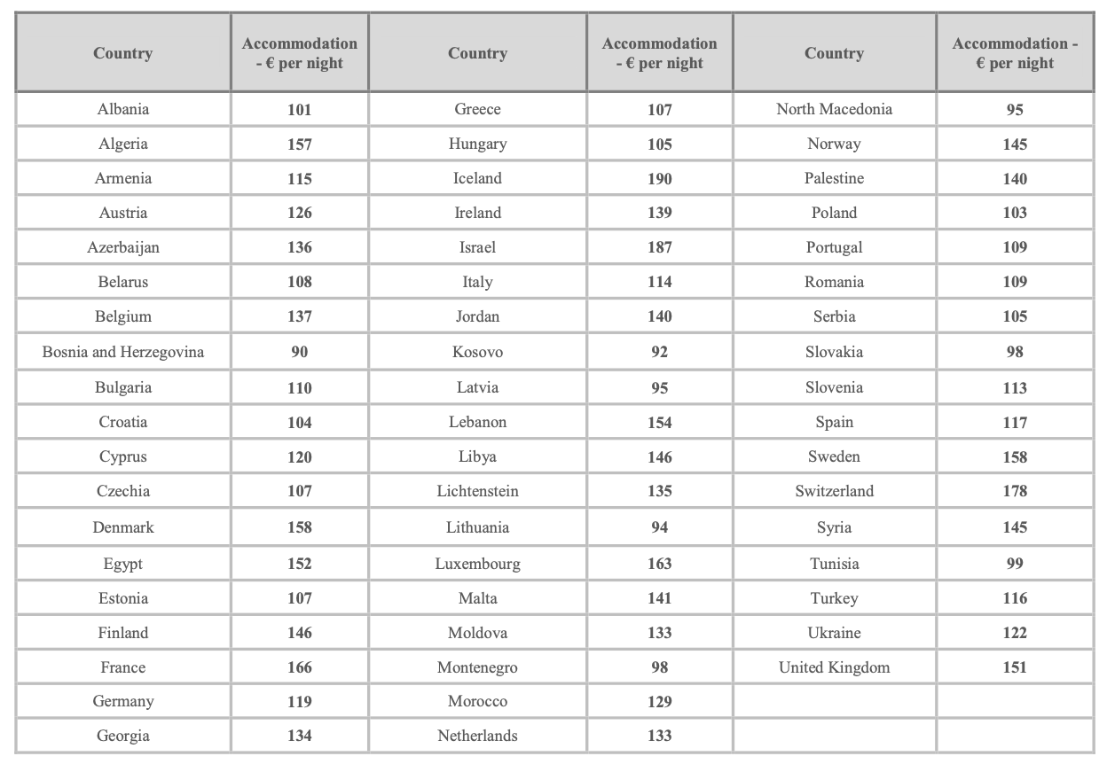
- Daily allowance rate: 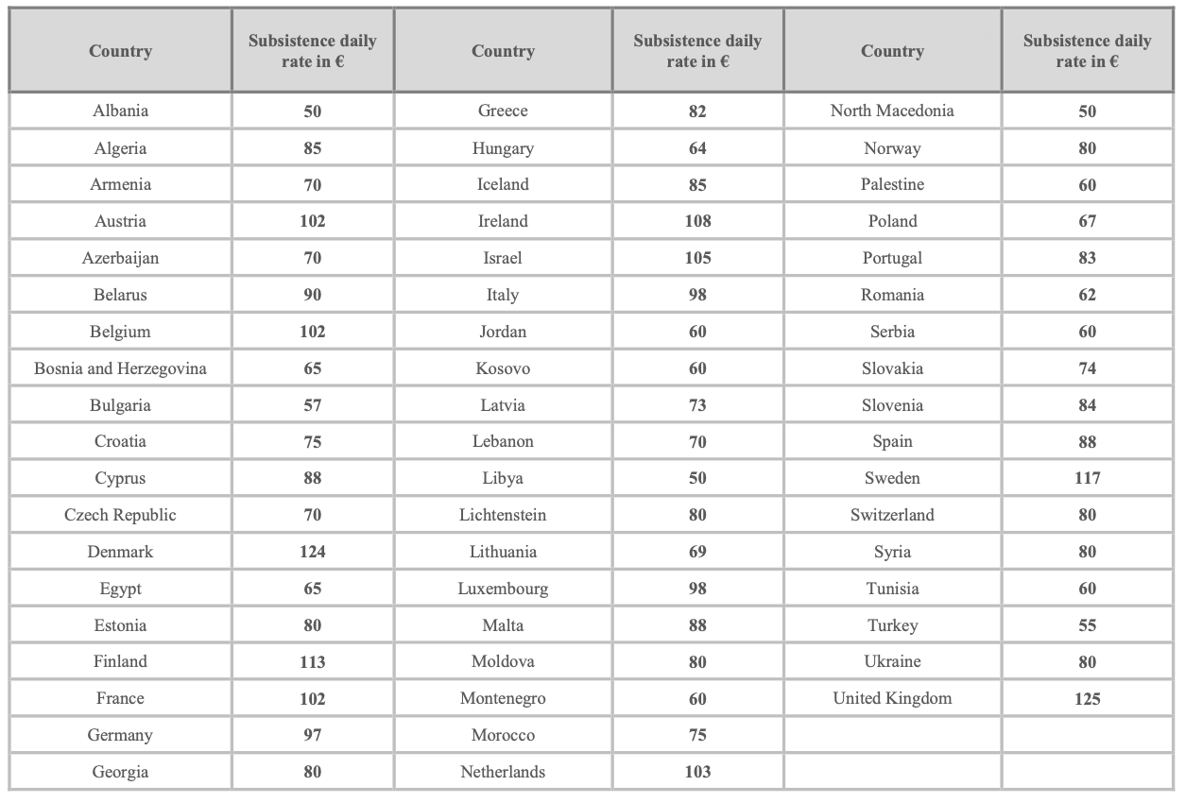
- Flight costs:
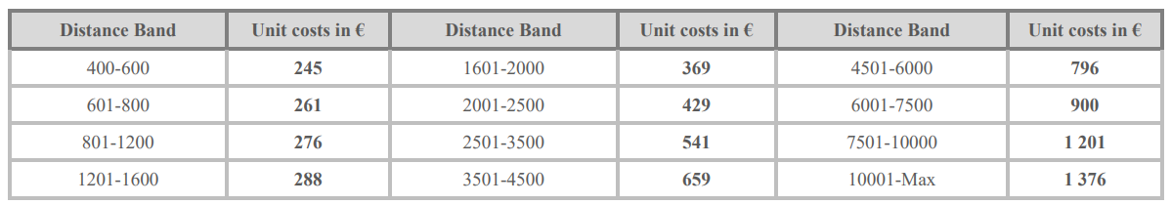
* All distances to be measured using the rail calculator or flight calculator. (Method: you enter the start and end of the return flight and look up the one-direction distance equivalent of the unit cost. The amount in EUR is meant to be per return trip!) For distances between 50-400 km please look at table in page 3.
- Amounts in EUR for Inter-Member States return journeys between 50-400 km
